Things You Should Know About Pre-installed SIM Card

Notice for Use
Please note that the included SIM card is only compatible with Imou 4G security cameras. Avoid inserting it into any smartphone or electronic product.
To ensure proper recognition and prevent the SIM card from getting stuck, please insert it properly as demonstrated in the Quick Start Guide.

SIM Card Compatible Network Carriers
We recommend using the SIM card included in the 4G security camera because it supports major mobile network service providers globally and can automatically activate upon initial device setup. However, if you prefer to use SIM cards from other mobile network service providers, that’s completely acceptable.
The list outlines the supported carriers for our pre-installed SIM cards in available countries and regions:
Country | Local Carriers
Austria | A1
Belgium | BASE (KPN Group Belgium)/Mobistar
Bulgaria | A1 Bulgaria
Croatia | A1 Hrvatska
Cyprus | CYTAmobile-Vodafone/Primetel
Czech Republic | Vodafone CZ/T-Mobile CZ
Denmark | TDC Mobil/Hutchison Denmark
Estonia | EMT - Estonian Mobile Telephone/Tele2 Eesti
Finland | DNA Finland/TeliaSonera
France | Orange France/SFR/Free Mobile
Germany | Vodafone/Telefónica O2 Germany/Telekom Deutschland
Greece | Vodafone/Wind Hellas
Hungary | Vodafone/T-Mobile
Iceland | Nova Iceland/Vodafone
Ireland | Telefonica O2 Ireland/Vodafone Ireland/Hutchison 3G Ireland
Italy | Vodafone-Omnitel/Hutchison 3G/Wind
Latvia | Bite Latvija/Tele2 Latvia
Liechtenstein | mobilkom liechtenstein
Lithuania | Bite/Tele 2 Lithuania
Luxembourg | Orange/TANGO
Malta | Vodafone Malta
Netherlands | Vodafone Netherlands/KPN
Norway | Telenor/TeliaSonera Norge
Poland | Orange/T-Mobile
Portugal | Vodafone Portugal/TMN Portugal
Romania | Vodafone Romania/Telekom Romania/RCS-RDS Romania/Orange Romania
Serbia | VIP mobile
Slovak Republic | Orange Slovensko/T-Mobile Slovensko
Slovenia | A1 Slovenija/Mobitel
Spain | Vodafone/Orange/O2 Spain
Sweden | Telenor Sverige/Tele2 Sverige
United Kingdom | Hutchison 3G UK/Orange (UK)/T-Mobile (UK)/Vodafone UK/MANX Telecom/Telefónica O2 UK

Managing SIM Card
Cellular Data Free Trial and Plan
Each pre-installed SIM card comes with complimentary data for network connectivity. After adding the camera to your account successfully, you will seize cellular data free trial. Please choose a data plan or top up in the APP for continuous use when the free trial ends.
Top Up Cellular Data
Here demonstrate how to access the top-up page and recharge cellular data for your pre-installed SIM card:
- SIM card icon on the Home page.
              - Home page
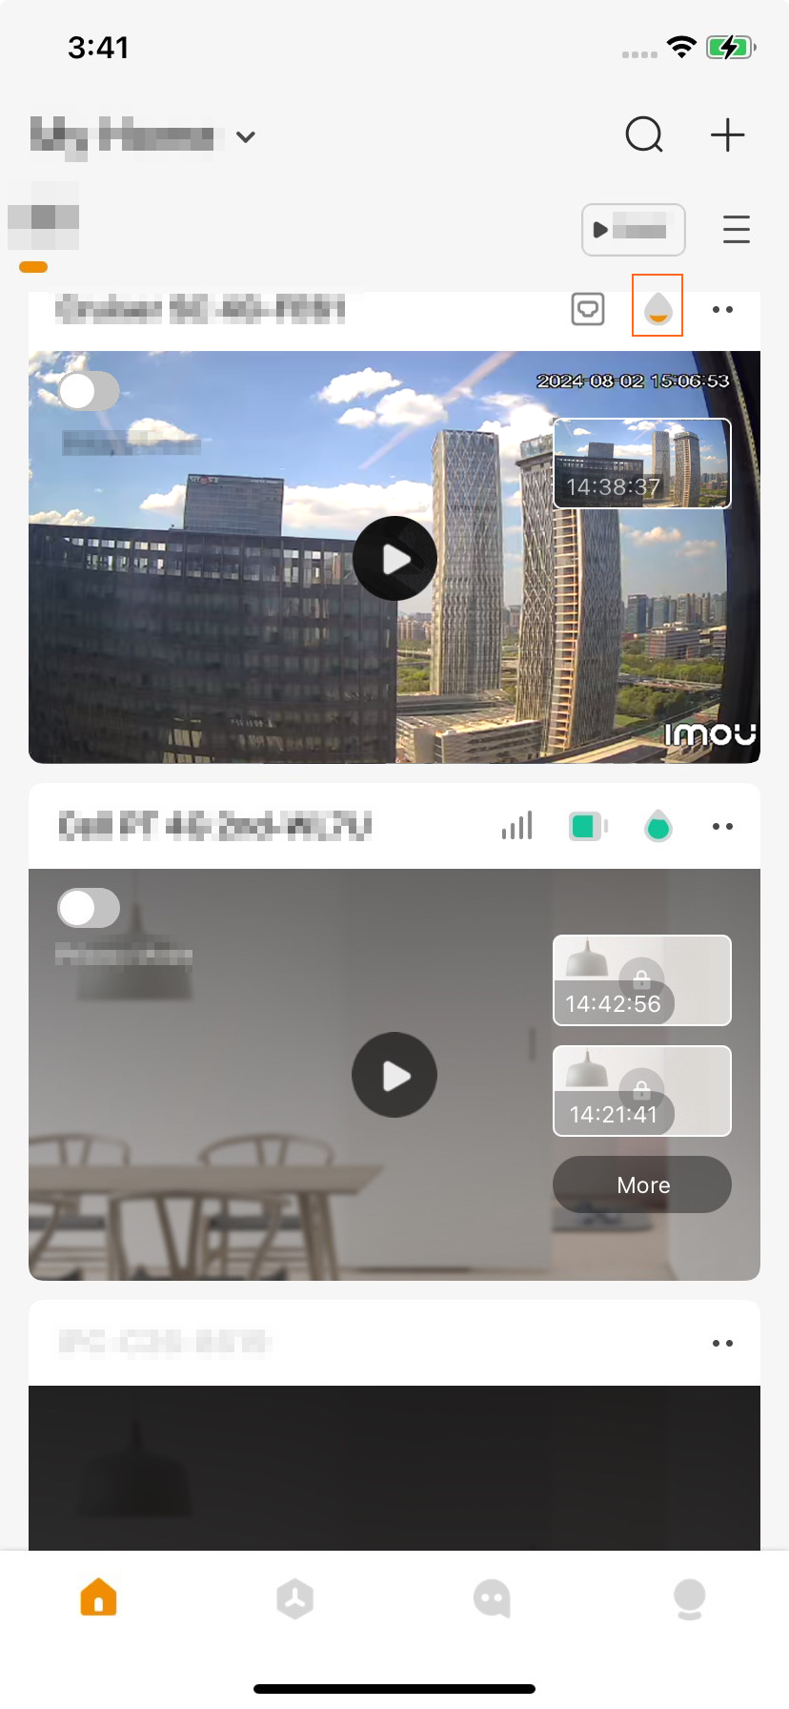
- Cellular Data banner on the Preview page.
              - Preview page
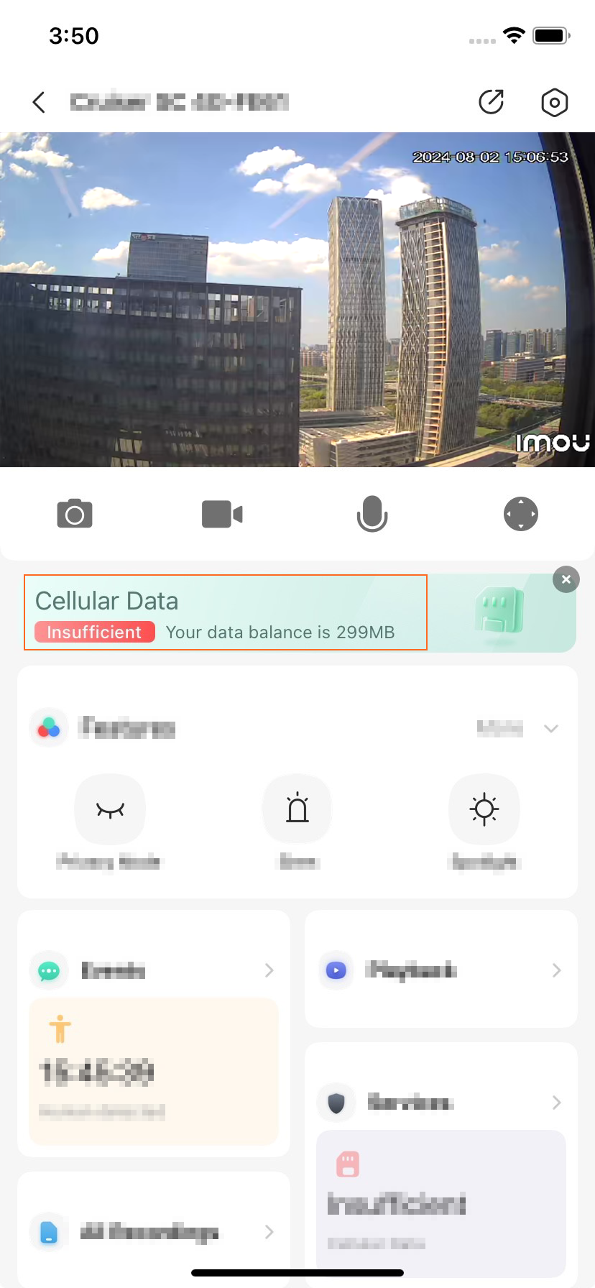
- 4G on Device Details page.
              - Device Details page
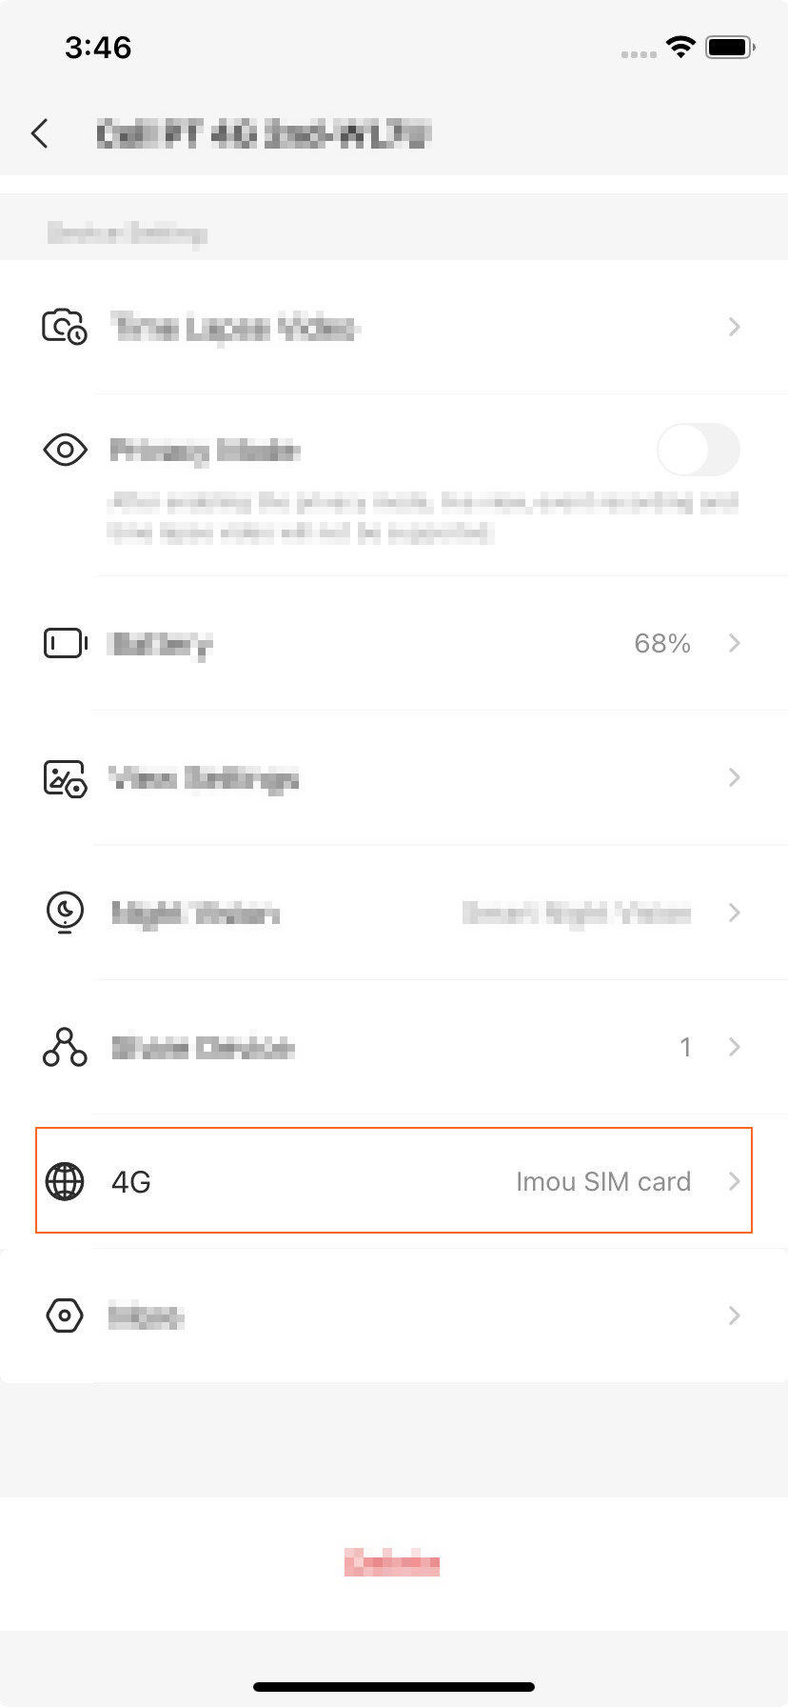
- Me＞Tools＞Purchase Cellular Data.
              - Me page
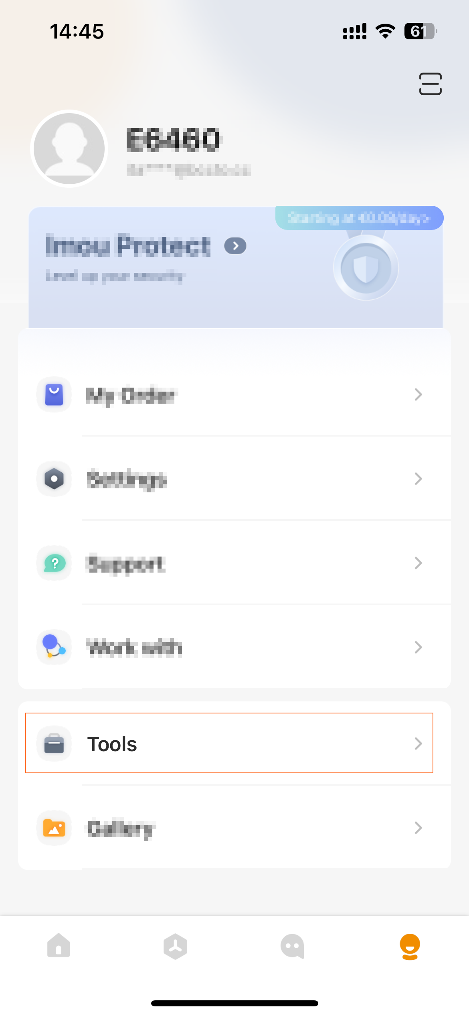
              - Tools page
